<https://dev.mysql.com/downloads/installer/>

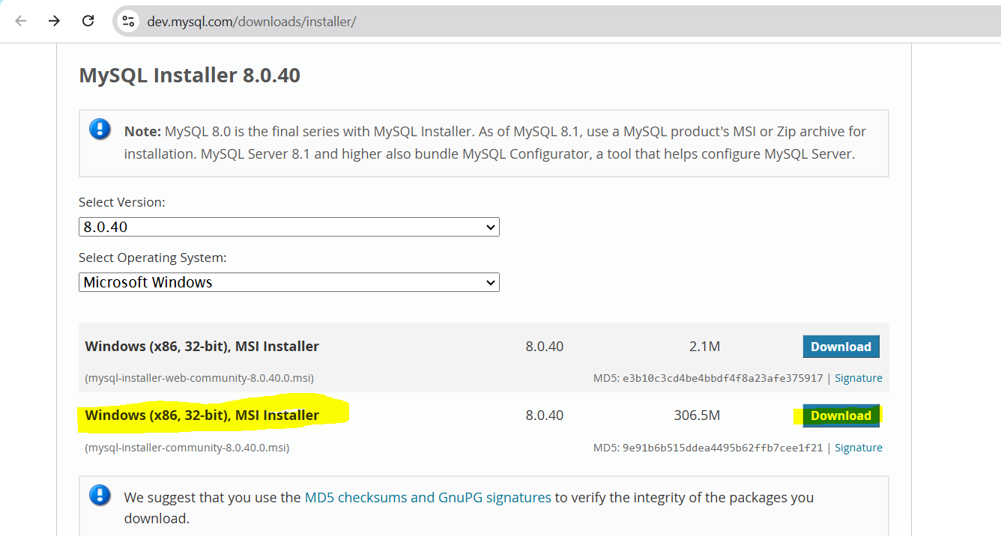

<https://www.dataquest.io/blog/install-mysql-windows/>

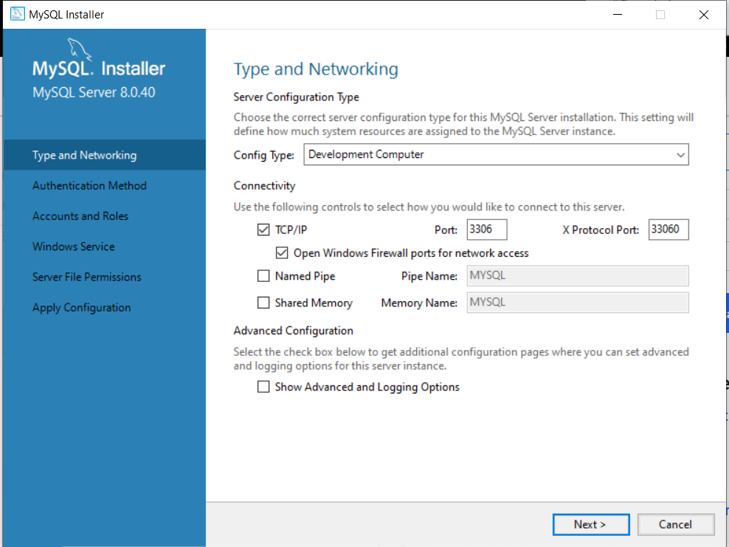

Username – root

Password – mysql@123